How Power-line Networking Works
Power-line networking is one of several ways to connect the computers in your home. It uses the electrical wiring in your house to create a network.
In this edition of HowStuffWorks, we'll talk about power-line networking and the technology used to make it happen. We'll also discuss the advantages and disadvantages of using a power-line network.
The Technology
Like HomePNA, power-line networking is based on the concept of "no new wires." The convenience is even more obvious in this case because while not every room has a phone jack, you will always have an electrical outlet near a computer. In power-line networking, you connect your computers to one another through the same outlet.
Because it requires no new wiring, and the network adds no cost to your electric bill, power-line networking is the cheapest method of connecting computers in different rooms.
Pros and Cons
There are two competing power-line technologies. The original technology is called Passport, by a company named Intelogis. A new technology called PowerPacket, developed by Intellon, has been chosen by the HomePlug Alliance as the standard for power-line networking.
Here are the advantages of a power-line network:
- It's inexpensive. (This author bought a complete Intelogis' PassPort kit to connect two computers for $50.)
- It uses existing electrical wiring.
- Every room of a typical house has several electrical outlets.
- It's easy to install.
- A printer, or any other device that doesn't need to be directly connected to a computer, doesn't have to be physically near any of the computers in the network.
- It doesn't require that a card be installed in the computer (although there are companies working on PCI-based systems).
The new PowerPacket technology provides a couple of other advantages as well. It is fast, rated at 14 megabits per second (Mbps). This speed allows for new applications, such as audio and video streaming, to be available throughout the house.
There are some disadvantages to connecting through power-lines when using the older Intelogis technology:
- The connection is rather slow -- 50 Kbps to 350 Kbps.
- The performance can be impacted by home power usage.
- It can limit the features of your printer.
- It only works with Windows-based computers.
- It uses large wall devices to access an electrical outlet.
- It can only use 110-V standard lines.
- It requires that all data be encrypted for a secure network.
- Older wiring can affect performance.
According to Intellon, PowerPacket technology eliminates many of these concerns, citing the following advantages:
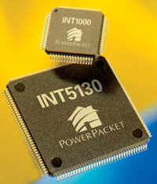
Photo courtesy Intellon
New power-line networking products are based on Intellon's PowerPacket technology.
- It is very fast, rated at 14 Mbps.
- It "avoids" disruptions in the power-line, maintaining the network's connections and speeds.
- It does not limit the features of your printer.
- It can be compatible with other operating systems (depending on driver availability).
- It may have the necessary circuitry embedded within the device, necessitating only a standard power cord to access an outlet.
- It works independent of line voltage and frequency of current.
- It includes encryption.
- In tests, it showed no signal degradation due to older wiring.
Now let's find out how each of these technologies works.
Methods
Intellon and Intelogis use different methods to establish power-line networks.
Intellon
Intellon's PowerPacket technology, which serves as the basis for the HomePlug Powerline Alliance standard, uses an enhanced form of orthogonal frequency-division multiplexing (OFDM) with forward error-correction, similar to the technology found in DSL modems. OFDM is a variation of the frequency-division multiplexing (FDM) used in phone-line networking. FDM puts computer data on separate frequencies from the voice signals being carried by the phone line, separating the extra signal space on a typical phone line into distinct data channels by splitting it into uniform chunks of bandwidth.
In the case of OFDM, the available range of frequencies on the electrical subsystem (4.3 MHz to 20.9 MHz) is split into 84 separate carriers. OFDM sends packets of data simultaneously along several of the carrier frequencies, allowing for increased speed and reliability. If noise or a surge in power usage disrupts one of the frequencies, the PowerPacket chip will sense it and switch that data to another carrier. This rate-adaptive design allows PowerPacket to maintain an Ethernet-class connection throughout the power-line network without losing any data.
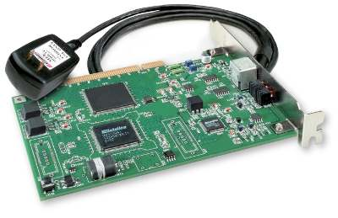
Photo courtesy Intellon
This card plugs into a PCI slot in your computer and into a wall outlet to create a power-line network.
The latest generation of PowerPacket technology is rated at 14 Mbps, which is faster than existing phone-line and wireless solutions. However, as broadband access and Internet-based content like streaming audio and video and voice-over-IP become more commonplace, speed requirements will continue to increase. Along these lines, Intellon's OFDM approach to power-line networking is highly scalable, eventually allowing the technology to surpass 100 Mbps.
Intelogis
The older power-line technology used by Intelogis relies on frequency-shift keying (FSK) to send data back and forth over the electrical wires in your home. FSK uses two frequencies, one for 1s and the other for 0s, to send digital information between the computers on the network. (See How Bits and Bytes Work to learn more about digital data.) The frequencies used are in a narrow band just above the level where most line noise occurs. Although this method works, it is somewhat fragile. Anything that impinges on either frequency can disrupt the data flow, causing the transmitting computer to have to resend the data. This can affect the performance of the network. For example, this author noticed that when he was using more electricity in the house, such as running the washer and dryer, the network slowed down. Intelogis includes line-conditioning power strips with its network kit and encourages you to insert them between the wall outlet and your computer equipment to help reduce the amount of electrical-line noise.
Because the current crop of power-line networks are designed to work on 110-volt electrical systems, the technology is not very useful to countries outside of North America that use different standards.
Cost And Installation
Intelogis provides a kit that connects two computers and one printer for $59. Additional adapters cost about $40. There are specific versions for computers or printers, so make sure you get the correct one. Since the network does not affect power usage or consumption, no additional monthly costs are incurred.
The cost of PowerPacket technology is expected to be comparable to HomePNA solutions and significantly less than 802.11 wireless solutions.
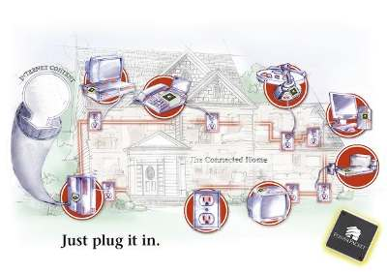
Image courtesy of Intellon
A power-line network provides access all over your home.
How to Install a Power-line Network
The physical connection between each computer and the Intelogis power-line network uses the computer's parallel port. A wall device is plugged directly into the electrical outlet (it will not operate properly if plugged into a surge protector).
A parallel cable is plugged into the wall device and into the parallel port of the computer. The power-line network must be the last item connected to the parallel port. For this reason, if you have anything else connected to the parallel port, such as a scanner or Zip drive, it must have a pass-through for the parallel port. Unless you have a second parallel port on your computer, your printer must be connected to the network through a wall device of its own. Something to keep in mind is that current power-line networks do not support bidirectional printing. "Bidirectional" means that data is sent in both directions, allowing your printer to send information back to your computer, such as how much ink is left and if there is a paper jam. This will not keep your printer from working, but it is worth noting that you will lose the use of such features.
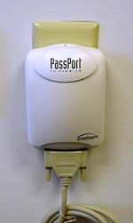
To install an Intelogis PassPort power-line network, you plug a wall device like this into an outlet.
Initial PowerPacket devices connect via a USB or Ethernet cord from the computer to a small wall adapter. Subsequent devices will have the circuitry built in, meaning the only connection needed would be the power cord.
Once the physical connections are made, installation of the software is a snap. The software automatically detects all nodes (computers and printers) on the network. Whether your Internet connection is by cable modem, DSL or normal modem, the included proxy server software allows you to share the Internet with your other computers. You can easily add computers by simply plugging a new adapter in and installing the software. Additional printers can be added using the printer plug-in adapter. File and printer sharing is done through Windows.
There are two common types of home networks: peer-to-peer and client/server. Client/server networks have a centralized administrative system that provides information to all of the other devices. Peer-to-peer means that each device can talk directly to each other device on the network without consulting a central system first. Intelogis Passport technology uses a client/server network. The first computer that you install the software on becomes the Application Server. In essence, it is the director of the network, controlling the flow of data and telling each device on the network where to find the other devices. Intellon's PowerPacket technology uses a peer-to-peer network.
The Future
Intellon's PowerPacket technology is compatible with wireless and HomePNA solutions, making power-line an ideal option to serve as the backbone for a multi-technology home network. In this case, consumers will not have to discard their existing network solutions in favor of a new standard.
The one common thread among all of the networking options is the need for power. While a wireless solution may indeed shun wires, its access point is still going to be plugged in at some point. That power cord, for example, can tie the wireless network into the home's overarching power-line network.
There are two other networking technologies to discuss: phone-line and wireless networks. Click on the title below to go to one of these articles for more information, or proceed to either A Word About Macs or The Future of Home Networking.

